1. What is Serialization?
- Definition: Converting an object in memory into a stream of bytes for storage or transfer.
- Purpose: To save an object's state permanently or send it over a network.
- Deserialization: The reverse process—reconstructing the object from the byte stream back into memory.
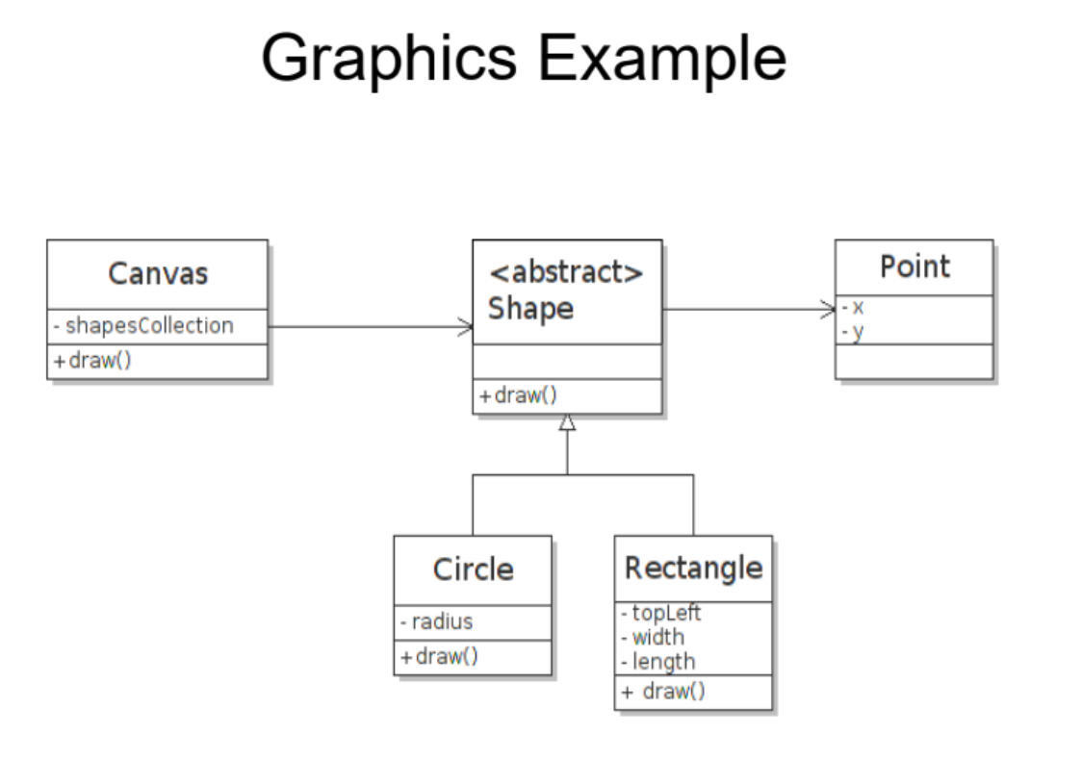
2. Graphics Example (Classes)
A simple drawing application with these classes:
- Point: Has x and y coordinates.
- Shape: An abstract class with a Point and a draw() method.
- Circle & Rectangle: Specific shapes that extend Shape, adding their own properties (e.g., radius for Circle).

3. How Objects Look in Memory
- An object is stored at a memory address (e.g., 0x100).
- Its data (like x and y values for a Point) is stored in consecutive memory blocks.
- Different objects (like p1 and p2) exist at different memory addresses.
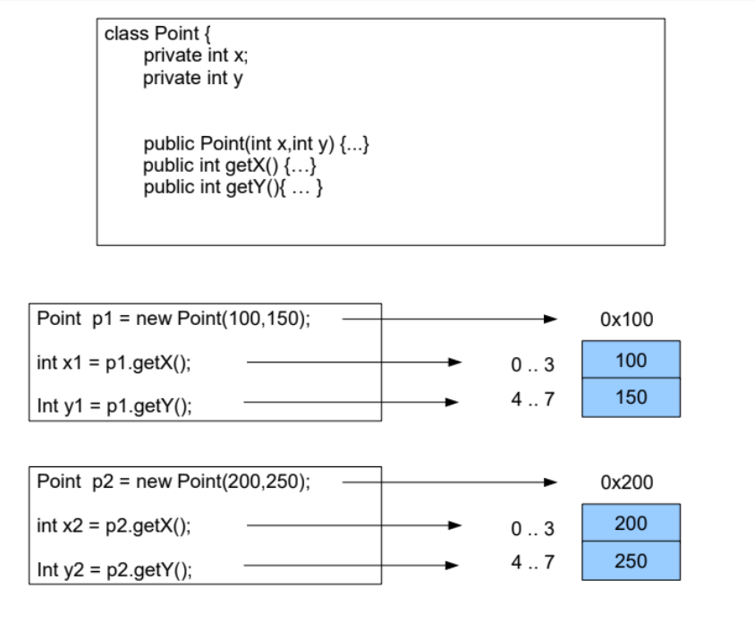

4. Object Relationships in Memory
- A Circle object contains:
  - A pointer (memory address) to its Point object.
  - Its own data (the radius).
- Multiple objects can point to the same Point in memory (shared data).
- 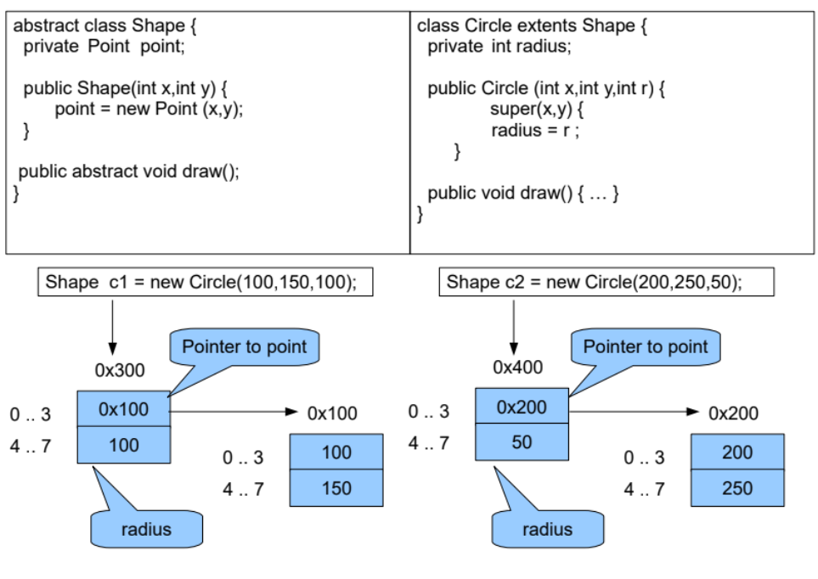

5. Serialization Formats: Two Approaches
Option A: Without Pointers (Flattened)
- The entire object structure is written out in a linear sequence.
- All data is duplicated, even if it was shared in memory.
- Example: Circle writes: [8, 100, 150, 100] (type, x, y, radius).
Option B: With Pointers (Preserves Structure)
- The serialized data maintains the original object relationships and pointers.
- Shared objects are stored once and referenced by ID.
- More complex but preserves memory structure accurately.
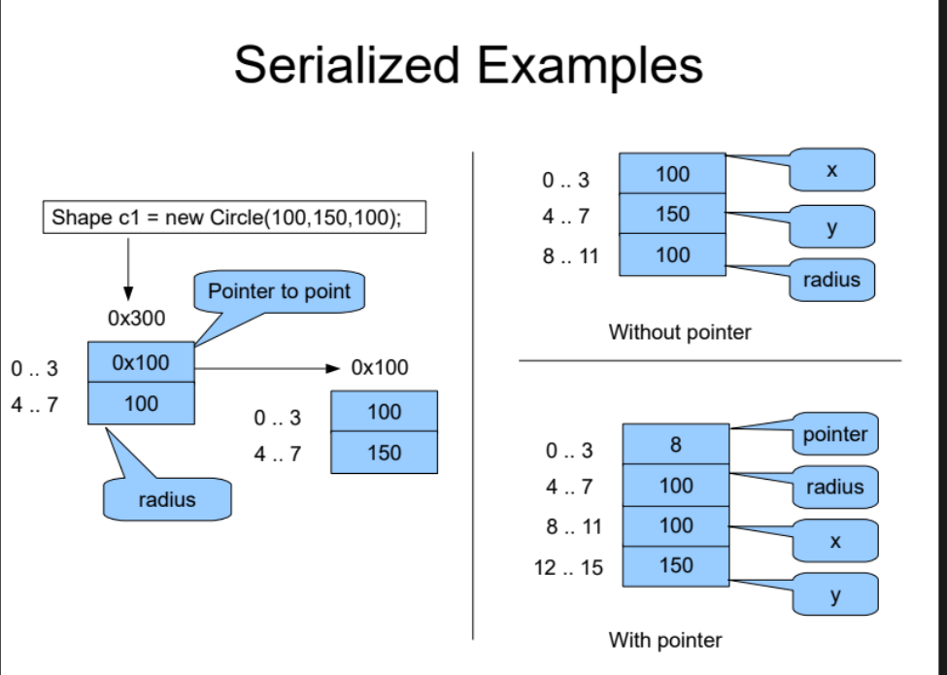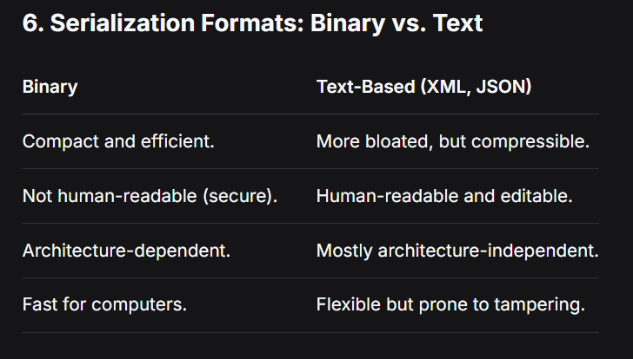

7. XML Serialization Example
- Represents the Circle object as nested tags.
- Without pointers: All data is written directly inside the <circle> tag.
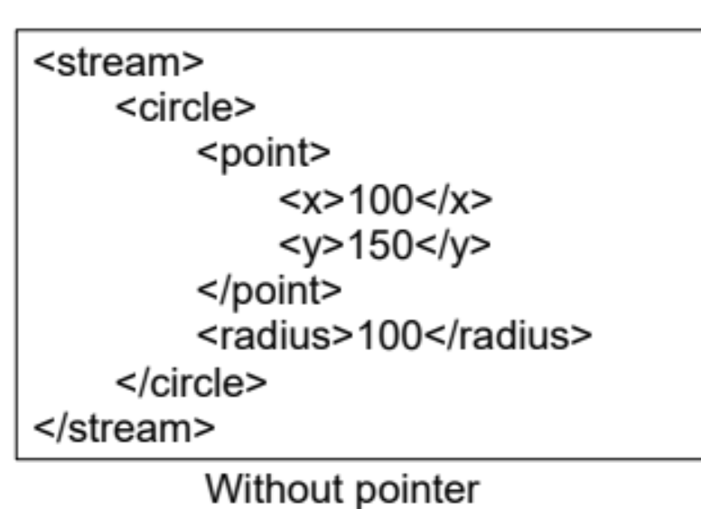
- With pointers: Uses references (e.g., <point type="pointer">1</point>) and a separate <point> definition with an id.
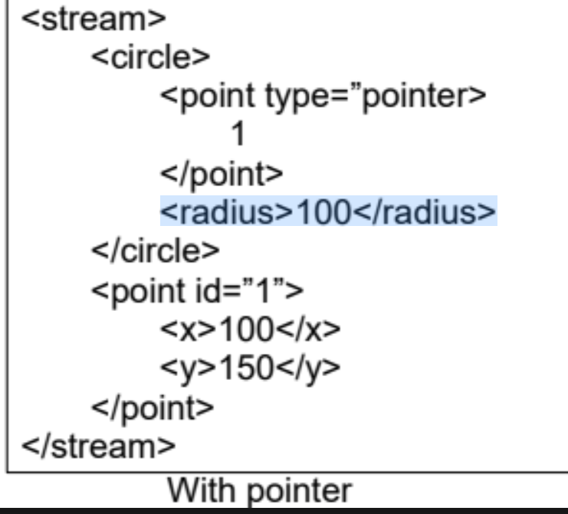

8. JSON Serialization Example
- Represents the Circle as a key-value object.
- Without pointers:
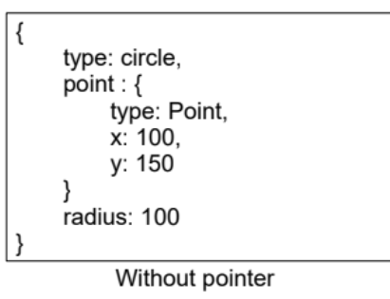
- With pointers: Uses a reference system where the point is an object containing a pointer ID, and the actual Point is defined separately in an array.
